**Pubmed web crawler coding challenge**

Search keywords from the two list giving below on pubmed together, and then store all the returning papers’ title, abstract and PMID (DOI number if it exits). In addition, please change the display settings from 20 to the maximum papers per page to facilitate the crawling efficiency.

Note: Consider the situation when there is no returning results.

**Example:**

**Input list 1:** [Akkermansia, Blastocatellaceae, Flavobacteriia]

**Input list 2:** [leukaemia, T2D, Crohn’s disease, ulcerative colitis]

**Output:**

1. All the searched term pair will generate a file which contains the extracted information

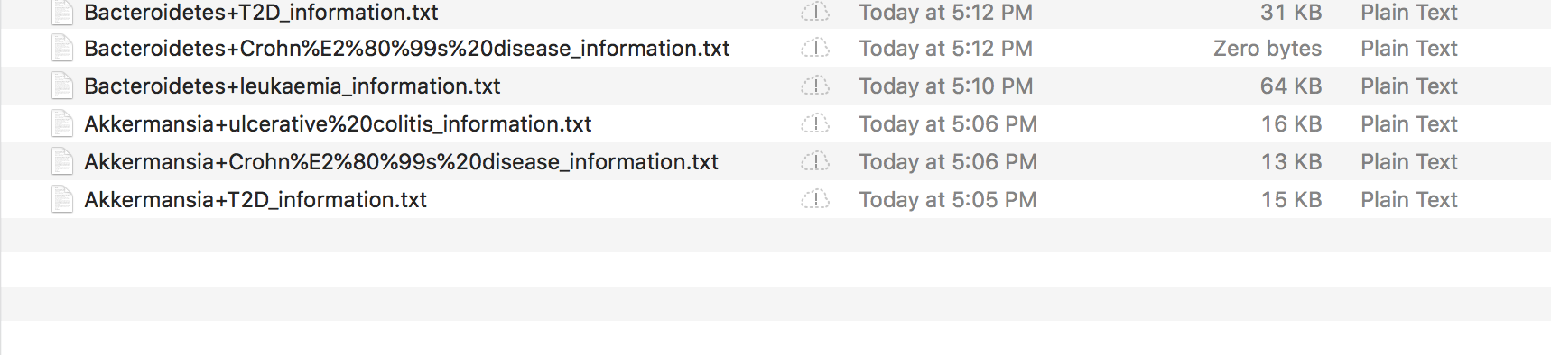

2. Each file will contains the entire extracted results, feel free to do some further modification.

